**Experiment 1 – LED Blinking**

* **Aim:**Todesign a LED flasher.
* **Apparatus:**Arduino Board, LED, Resistance - 220ohm, Breadboard, Wires.

**Circuit Diagram:**

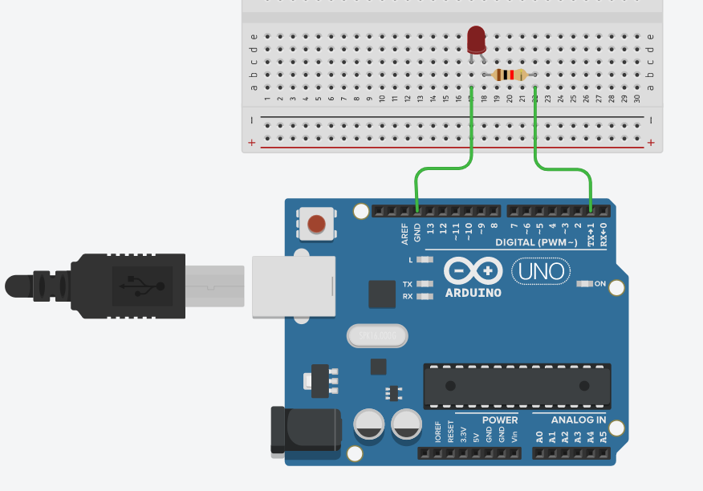

**Theory:**

Concept Used: In this experiment we have done coding to flash LED (Light Emitting Diode), which is held together on the Breadboard . LED flashers are semiconductor integrated circuits used to turn on and off groups of light emitting diodes either sequentially or according to a programmed pattern. Learning and Observations : Arduino is a single-board microcontroller meant to make the application more accessible which are interactive objects and its surroundings .This micro controller gives the valid instruction to the elements fitted on the breadboard according to coding done on software.

**Learning and Observations :**

Arduino is a single-board microcontroller meant to make the application more accessible which are interactive objects and its surroundings .This micro controller gives the valid instruction to the elements fitted on the breadboard according to coding done on software.

**Precautions:**

1--Postive and Negative terminals should be put in correct order. 2-All the wires and elements should be connected tightly and according to the coding done on the system.

3- The coding done on the software should be correct in every manner. All the errors should be avoided i.e. syntax,logical errors etc..

**Learning Outcomes:-**

* I have learned how to make circuits using an arduino board and a bread board.
* Through this experiment, I have gained the skill of controlling the functions done by the circuit with the help of codes.